**LAB 5**

# Exercise 1:

Design a proper interface of a calculator using Html , CSS and javaScript.Enhance the given example in the given manual and create a scientific calculator using Math object. That must include following operations. Square root of a number , logarithm , trignomatric functions, quadratic eqation, square of a number cube of a number.

<!DOCTYPE html>  
<html lang="en">  
<head>  
 <meta charset="UTF-8">  
 <meta name="viewport" content="width=device-width, user-scalable=no, initial-scale=1.0, maximum-scale=1.0,  
 minimum-scale=1.0">  
 <meta http-equiv="X-UA-Compatible" content="ie=edge">  
  
 <title>Scientific Calculator Tutorial</title>  
 <link rel="stylesheet" href="t1.css">  
</head>  
<body onload="startTime()">  
<div class="cal-container">  
  
 <!-- clock-->  
 <div class="clock">  
 <p id="time">time goes here</p>  
 </div>  
  
 <!-- screen-->  
 <div class="display">  
 <input type="text" id="screen" placeholder="0" readonly>  
 </div>  
  
 <!-- calculator buttons -->  
 <div class="keys">  
 <p>  
 <input type="button" value="sin" class="btn btn-sign" onclick="sine()">  
 <input type="button" value="cos" class="btn btn-sign" onclick="cosine()">  
 <input type="button" value="tan" class="btn btn-sign" onclick="tan()">  
 <input type="button" value="asin" class="btn btn-sign" onclick="invsine()">  
 <input type="button" value="acos" class="btn btn-sign" onclick="invcosine()">  
 </p>  
 <p>  
 <input type="button" value="atan" class="btn btn-sign" onclick="invtan()">  
 <input type="button" value="π" class="btn btn-sign" onclick="press('22/7')">  
 <input type="button" value="ln" class="btn btn-sign" onclick="ln()">  
 <input type="button" value="log" class="btn btn-sign" onclick="log()">  
 <input type="button" value="%" class="btn btn-sign" onclick="percent()">  
 </p>  
 <p>  
 <input type="button" value="sqd" class="btn btn-sign" onclick="sqrt()">  
 <input type="button" value="cube" class="btn btn-sign" onclick="cube()">  
 <input type="button" value="√" class="btn btn-sign" onclick="sqrt()">  
 <input type="button" value="(" class="btn btn-sign" onclick="press('(')">  
 <input type="button" value=")" class="btn btn-sign" onclick="press(')')">  
 </p>  
  
 <p style="margin-top: 30px;">  
 <input type="button" value="7" class="btn btn-num" onclick="press(7)">  
 <input type="button" value="8" class="btn btn-num" onclick="press(8)">  
 <input type="button" value="9" class="btn btn-num" onclick="press(9)">  
 <input type="button" value="Del" class="btn btn-red" onclick="backSpace()">  
 <input type="button" value="C" class="btn btn-red" onclick="clearScreen('')">  
 </p>  
  
 <p>  
 <input type="button" value="4" class="btn btn-num" onclick="press(4)">  
 <input type="button" value="5" class="btn btn-num" onclick="press(5)">  
 <input type="button" value="6" class="btn btn-num" onclick="press(6)">  
 <input type="button" value="x" class="btn btn-opera" onclick="press('*')">  
 <input type="button" value="/" class="btn btn-opera" onclick="press('/')">  
 </p>  
  
 <p>  
 <input type="button" value="1" class="btn btn-num" onclick="press(1)">  
 <input type="button" value="2" class="btn btn-num" onclick="press(2)">  
 <input type="button" value="3" class="btn btn-num" onclick="press(3)">  
 <input type="button" value="+" class="btn btn-opera" onclick="press('+')">  
 <input type="button" value="-" class="btn btn-opera" onclick="press('-')">  
 </p>  
  
 <p>  
 <input type="button" value="0" class="btn btn-num" onclick="press(0)">  
 <input type="button" value="±" class="btn btn-opera" onclick="plusminus()">  
 <input type="button" value="." class="btn btn-num" onclick="press('.')">  
 <input type="button" value="Exp" class="btn btn-opera" onclick="Exp()">  
 <input type="button" value="=" class="btn btn-opera" onclick="calculate()">  
 </p>  
 </div>  
</div>  
  
  
<script src="t1.js"></script>  
</body>  
</html>

body{  
 background-color: white;  
}  
  
.cal-container{  
 background: #222;  
 width: 300px;  
 height: 520px;  
 text-align: center;  
 border-radius: 10px;  
 border: 5px solid black;  
 margin-left: 50px;  
 border-right: 10px solid black;  
 border-bottom: 10px solid black;  
}  
  
.clock{  
 position: relative;  
 top: 15px;  
 height: 40px;  
 width: 110px;  
 border-radius: 4px;  
 left: 170px;  
 background: black;  
 text-align: center;  
}  
  
#time{  
 color: black;  
 position: relative;  
 background: red;  
 width: 100px;  
 height: 25px;  
 top: 3px;  
 left: 3px;  
 padding-top: 6px;  
 text-align: center;  
 border: 2px solid white;  
 border-radius: 3px;  
}  
  
.display{  
 background-color: black;  
 height: 45px;  
 position: relative;  
 display: inline-block;  
 top: 30px;  
 width: 265px;  
 border-radius: 5px;  
}  
  
#screen{  
 position: relative;  
 height: 33px;  
 top: 2.5px;  
 width: 253px;  
 background: #bccd95;  
 text-align: right;  
 font-size: 1.5em;  
 border-radius: 5px;  
}  
  
.keys{  
 position: relative;  
 top: 40px;  
}  
  
.btn{  
 color: black;  
 background: lightsteelblue;  
 cursor: pointer;  
 width: 40px;  
 margin: 2px 2px 2px 4px;  
 font-size: 0.9em;  
 text-align: center;  
 border: none;  
 border-top: 2px solid transparent;  
 padding: 3px;  
}  
  
.btn-sign{  
 background: #413c3c;  
 color: white;  
 border-radius: 12px;  
 border-top: 2px solid #413c3c;  
 border-bottom: 2px solid black;  
}  
  
.btn-sign:active{  
 border-bottom: 2px solid #413c3c;  
 border-top: 2px solid #000;  
}  
  
.btn-num{  
 background-color: black;  
 color: white;  
 font-size: 1.1em;  
 border-radius: 6px;  
 border-bottom: 2px solid #3b3737;  
 border-top: 2px solid black;  
}  
  
.btn-num:active{  
 border-top: 2px solid #3b3737;  
 border-bottom: 2px solid black;  
}  
  
.btn-red{  
 background: red;  
 padding: 4px;  
 color: #000;  
 font-size: 1.1em;  
 border-radius: 4px;  
 border-bottom: 2px solid #000000;  
 border-top: 2px solid red;  
 font-weight: 600;  
}  
  
.btn-red:active{  
 border-top: 2px solid #000000;  
 border-bottom: 2px solid red;  
}  
  
.btn-opera{  
 background: #111;  
 color: white;  
 padding: 4px;  
 font-size: 1.1em;  
 border-radius: 5px;  
 border-bottom: 2px solid #000;  
 border-top: 2px solid #111;  
}  
  
.btn-opera:active{  
 border-top: 2px solid #000;  
 border-bottom: 2px solid #111;  
}

function startTime() {  
 let today = new *Date*();  
 let hours = today.getHours();  
 let minutes = today.getMinutes();  
 let seconds = today.getSeconds();  
  
 //time format  
 if(hours > 12){  
 hours = hours - 12;  
 }  
  
 // add zero if less than 10  
 hours = concatZero(hours);  
 minutes = concatZero(minutes);  
 seconds = concatZero(seconds);  
  
 // am pm  
 let mode;  
 if(hours < 11){  
 mode = 'PM';  
 }  
 else{  
 mode = 'AM';  
 }  
 *document*.getElementById("time").innerHTML = hours + ':' + minutes + ':' + seconds + ' ' + mode;  
 setTimeout(startTime, 500);  
}  
startTime();  
  
function concatZero(value){  
 if(value< 10){  
 value = '0' + value;  
 }  
 return value;  
}  
  
//screen  
let *screen* = *document*.getElementById("screen");  
  
//type to the screen  
function press(numValue){  
 if(*screen*.value === 0){  
 *screen*.value = ' ';  
 }  
 *screen*.value += numValue;  
}  
  
//clear screen  
function clearScreen(val){  
 *screen*.value = val;  
}  
  
//Delete key  
function backSpace(){  
 const space = *screen*;  
 *screen*.value = space.value.substring(0, space.value.length - 1);  
}  
  
//calculate function  
function calculate(){  
 if (*screen*.value !== ''){  
 try{  
 clearScreen(eval(*screen*.value));  
 }  
 catch(err){  
 clearScreen("Bad expression")  
 }  
 }  
}  
  
//calculate the sine, cosine and tan of an angle in DEG  
function sine(){  
 *screen*.value = *Math*.sin(*screen*.value * *Math*.PI/180);  
}  
  
function cosine(){  
 *screen*.value = *Math*.cos(*screen*.value * *Math*.PI/180);  
}  
  
function tan(){  
 *screen*.value = *Math*.tan(*screen*.value * *Math*.PI/180);  
}  
  
//Function to calculate asin, acos and atan  
  
function invsine(){  
 *screen*.value = *Math*.asin(*screen*.value) * (180/*Math*.PI);  
}  
  
function invcosine(){  
 *screen*.value = *Math*.acos(*screen*.value) * (180/*Math*.PI);  
}  
  
function invtan(){  
 *screen*.value = *Math*.acos(*screen*.value) * (180/*Math*.PI);  
}  
  
//Function to calculate the natural logarithm  
function ln(){  
 *screen*.value = *Math*.log(*screen*.value);  
}  
  
function log(){  
 *screen*.value = *Math*.log10(*screen*.value);  
}  
  
function percent(){  
 *screen*.value = (*screen*.value/100);  
}  
  
function square(){  
 *screen*.value = *Math*.pow(*screen*.value, 2);  
}  
  
function cube(){  
 *screen*.value = *Math*.pow(*screen*.value, 3);  
}  
  
function sqrt(){  
 *screen*.value = *Math*.sqrt(*screen*.value);  
}  
  
function plusminus(){  
 let x = *screen*;  
 let y = x.value;  
 y = y * -1;  
 x.value = y;  
}  
  
function Exp(){  
 *screen*.value = *Math*.pow(10, *screen*.value);  
}

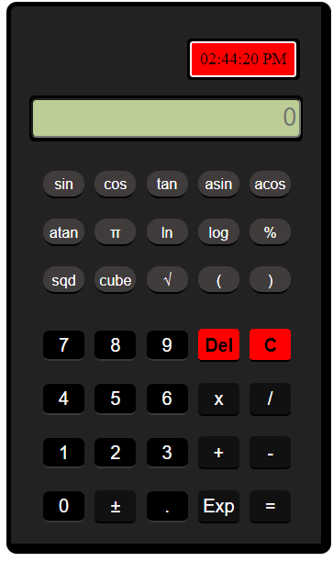

# Exercise 2:

Create a web page to get the First and Last Day of a Given Month using JavaScript.

<!DOCTYPE html>  
<html lang="en">  
<head>  
 <meta charset="UTF-8">  
 <title>First and Last Day of a Month</title>  
 <style>  
 body {  
 width: 100%;  
 height: 100vh;  
 margin: 0;  
 background-color: #1b1b32;  
 color: #f5f6f7;  
 font-family: Tahoma;  
 font-size: 16px;  
  
 }  
  
 button {  
 cursor: pointer;  
 color: #0a0a23;  
 background-color: #feac32;  
 background-image: linear-gradient(#fecc4c, #ffac33);  
 border: 3px solid #feac32;  
 margin: 1.1rem 0;  
 display: block;  
 width: 100%;  
 height: 2.2rem;  
 font-size: 1.1rem;  
 min-width: 300px;  
 }  
  
 h1 {  
 margin: 1em auto;  
 text-align: center;  
 }  
  
 form {  
 width: 60vw;  
 max-width: 500px;  
 min-width: 300px;  
 margin: 0 auto;  
 padding-bottom: 2em;  
 }  
  
 fieldset {  
 border: none;  
 padding: 2rem 0;  
 border-bottom: 3px solid #3b3b4f;  
 }  
  
 label {  
 display: block;  
 margin: 0.5rem 0;  
 }  
  
 input {  
 margin: 10px 0 0 0;  
 width: 100%;  
 min-height: 2em;  
 background-color: #0a0a23;  
 border: 1px solid #0a0a23;  
 color: #ffffff;  
 }  
  
 #result {  
 text-align: center;  
 font-size: 25px;  
 }  
 </style>  
</head>  
<body>  
<h1>First and Last Day of a Month</h1>  
<form method="post">  
 <fieldset>  
 <label for="month">Month:</label>  
 <input type="number" id="month" name="month" min="1" max="12"><br>  
 <label for="year">Year:</label>  
 <input type="number" id="year" name="year"><br>  
 </fieldset>  
 <button onclick="*event*.preventDefault(); calculate()">Calculate</button>  
</form>  
<p id="result"></p>  
<script>  
 function calculate() {  
 let month = *document*.getElementById("month").value;  
 let year = *document*.getElementById("year").value;  
 let date = new *Date*(year, month - 1);  
 let firstDay = new *Date*(date.getFullYear(), date.getMonth(), 1);  
 let lastDay = new *Date*(date.getFullYear(), date.getMonth() + 1, 0);  
 *document*.getElementById("result").innerHTML = "First Day: " + firstDay.toDateString() + "<br><br>Last Day: " + lastDay.toDateString();  
 }  
</script>  
</body>  
</html>

# Exercise 3:

Create a web page that ask the user to perform any of the following options.

1. Write a JavaScript function that reverse a number. Sample Data and output: Example x = 32243; Expected Output : 34223
2. Write a JavaScript function that returns a passed string with letters in alphabetical order. Example string : 'webmaster' Expected Output : 'abeemrstw'
3. Create a button, when user presses on it, it displays an error message using alert box if user entered a negative number.
4. 2. Display odd numbers from 1 to the number entered by user as input in prompt box. Generate an error message if a negative number is entered.
5. <!DOCTYPE html>  
   <html>  
   <head>  
    <title>JavaScript Functions</title>  
    <style>  
    body {  
    width: 100%;  
    height: 100vh;  
    margin: 0;  
    background-color: #1b1b32;  
    color: #f5f6f7;  
    font-family: Tahoma;  
    font-size: 16px;  
     
    }  
    button {  
    cursor: pointer;  
    color: #0a0a23;  
    background-color: #feac32;  
    background-image: linear-gradient(#fecc4c, #ffac33);  
    border: 3px solid #feac32;  
    margin: 1.1rem 0;  
    display: block;  
    width: 100%;  
    height: 2.2rem;  
    font-size: 1.1rem;  
    min-width: 300px;  
    }  
    h1 {  
    margin: 1em auto;  
    text-align: center;  
    }  
    #result{  
    text-align: center;  
    margin: 5px;  
    font-size: 26px;  
    }  
     
     
    </style>  
   </head>  
   <body>  
   <h1>JavaScript Functions</h1>  
   <button onclick="reverseNumber()">Reverse Number</button>  
   <button onclick="sortString()">Sort String</button>  
   <button onclick="checkNegative()">Check Negative Number</button>  
   <button onclick="displayOddNumbers()">Display Odd Numbers</button>  
   <p id="result"></p>  
     
   <script>  
    function reverseNumber() {  
    let num = prompt("Enter a number to reverse");  
    let reversed = num.split('').reverse().join('');  
    *document*.getElementById("result").innerHTML = "Reversed Number: " + reversed;  
    }  
     
    function sortString() {  
    let str = prompt("Enter a string to sort");  
    let sorted = str.split('').sort().join('');  
    *document*.getElementById("result").innerHTML = "Sorted String: " + sorted;  
    }  
     
    function checkNegative() {  
    let num = prompt("Enter a number");  
    if (num < 0) {  
    alert("Error: Number is negative");  
    } else {  
    alert("Number is positive");  
    }  
    }  
     
    function displayOddNumbers() {  
    let num = prompt("Enter a number");  
    if (num < 0) {  
    alert("Error: Number is negative");  
    } else {  
    let oddNumbers = [];  
    for (let i = 1; i <= num; i++) {  
    if (i % 2 !== 0) {  
    oddNumbers.push(i);  
    }  
    }  
    *document*.getElementById("result").innerHTML = "Odd Numbers: " + oddNumbers.join(', ');  
    }  
    }  
   </script>  
   </body>  
   </html>

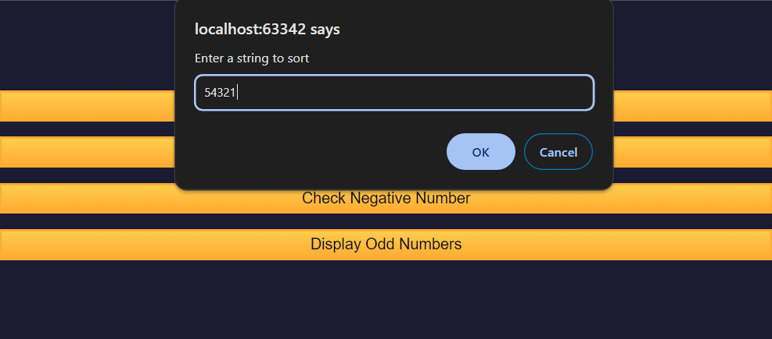

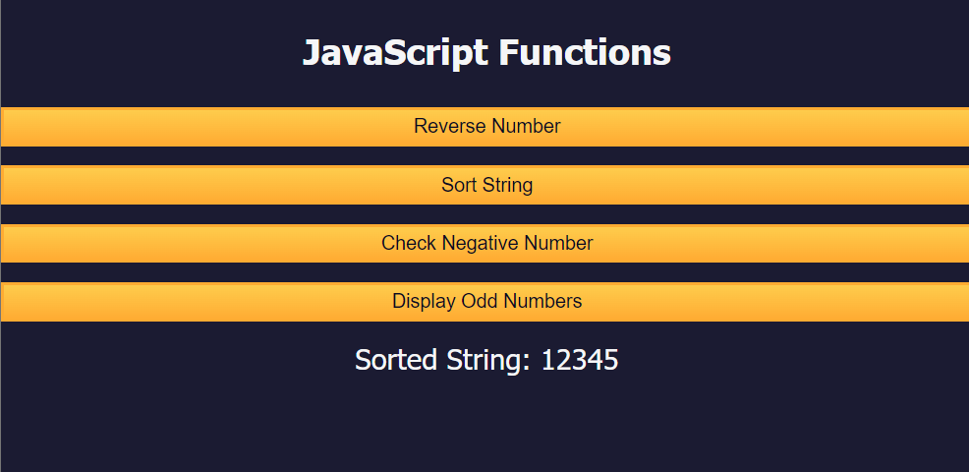

# Exercise 4:

Create a web page for fast food center. User can order three type of dishes:

1. Starters
2. Major Foods
3. Deserts

User can order for more than two meals at a time from above. Multi selection shall be based on list box, which holds multiple food items.

Display the order in a text area with the final order and its Bill accordingly.

<!DOCTYPE html>  
<html lang="en">  
<head>  
 <meta charset="utf-8" />  
 <meta name="viewport" content="width=device-width, initial-scale=1.0" />  
 <title>Cafe Menu</title>  
 <link href="t4.css" rel="stylesheet"/>  
</head>  
<body>  
<div class="menu">  
 <main>  
  
 <h1>CAMPER CAFE</h1>  
 <p class="established">Est. 2020</p>  
 <hr>  
 <form>  
 <section>  
 <h2>Coffee</h2>  
 <img src="https://cdn.freecodecamp.org/curriculum/css-cafe/coffee.jpg" alt="coffee icon"/>  
 <article class="item">  
 <p class="flavor">French Vanilla</p><p class="price">3.00</p>  
 </article>  
 <article class="item">  
 <p class="flavor">Caramel Macchiato</p><p class="price">3.75</p>  
 </article>  
 <article class="item">  
 <p class="flavor">Pumpkin Spice</p><p class="price">3.50</p>  
 </article>  
 <article class="item">  
 <p class="flavor">Hazelnut</p><p class="price">4.00</p>  
 </article>  
 <article class="item">  
 <p class="flavor">Mocha</p><p class="price">4.50</p>  
 </article>  
 <select id="coffeeSelect" multiple>  
 <option value="">Select</option>  
 <option value="3.00">French Vanilla</option>  
 <option value="3.75">Caramel Macchiato</option>  
 <option value="3.50">Pumpkin Spice</option>  
 <option value="4.00">Hazelnut</option>  
 <option value="4.50">Mocha</option>  
 </select><br>  
 </section>  
 <section>  
 <h2>Desserts</h2>  
 <img src="https://cdn.freecodecamp.org/curriculum/css-cafe/pie.jpg" alt="pie icon"/>  
 <article class="item">  
 <p class="dessert">Donut</p><p class="price">1.50</p>  
 </article>  
 <article class="item">  
 <p class="dessert">Cherry Pie</p><p class="price">2.75</p>  
 </article>  
 <article class="item">  
 <p class="dessert">Cheesecake</p><p class="price">3.00</p>  
 </article>  
 <article class="item">  
 <p class="dessert">Cinnamon Roll</p><p class="price">2.50</p>  
 </article>  
 <select id="dessertSelect" multiple>  
 <option value="">Select</option>  
 <option value="1.50">Donut</option>  
 <option value="2.75">Cherry Pie</option>  
 <option value="3.00">Cheesecake</option>  
 <option value="2.50">Cinnamon Roll</option>  
 </select><br>  
 </section>  
  
 <button type="button" onclick="calculateBill()">Calculate Bill</button>  
 </form>  
 <h2>Your Order:</h2>  
 <textarea id="order" readonly></textarea>  
 </main>  
 <hr class="bottom-line">  
 <footer>  
 <p>  
 <a href="https://www.freecodecamp.org" target="_blank">Visit our website</a>  
 </p>  
 <p class="address">ABC Cafe</p>  
 </footer>  
 <script src="t4.js"></script>  
</div>  
</body>

body {  
 background-image: url(https://cdn.freecodecamp.org/curriculum/css-cafe/beans.jpg);  
 font-family: sans-serif;  
 padding: 20px;  
}  
  
h1 {  
 font-size: 40px;  
 margin-top: 0;  
 margin-bottom: 15px;  
}  
  
h2 {  
 font-size: 30px;  
}  
  
.established {  
 font-style: italic;  
}  
  
h1, h2, p {  
 text-align: center;  
}  
  
  
.menu {  
 width: 80%;  
 background-color: burlywood;  
 margin-left: auto;  
 margin-right: auto;  
 padding: 20px;  
 max-width: 500px;  
}  
  
img {  
 display: block;  
 margin-left: auto;  
 margin-right: auto;  
 margin-top: -25;  
}  
  
hr {  
 height: 2px;  
 background-color: brown;  
 border-color: brown;  
}  
  
.bottom-line {  
 margin-top: 25px;  
}  
  
h1, h2 {  
 font-family: Impact, serif;  
}  
  
.item p {  
 display: inline-block;  
 margin-top: 5px;  
 margin-bottom: 5px;  
 font-size: 18px;  
}  
  
.flavor, .dessert {  
 text-align: left;  
 width: 75%;  
}  
  
.price {  
 text-align: right;  
 width: 25%;  
}  
  
/* FOOTER */  
  
footer {  
 font-size: 14px;  
}  
  
.address {  
 margin-bottom: 5px;  
}  
  
a {  
 color: black;  
}  
  
a:visited {  
 color: black;  
}  
  
a:hover {  
 color: brown;  
}  
  
a:active {  
 color: brown;  
}  
  
select{  
 cursor: pointer;  
 color: #0a0a23;  
 background-color: #b79053;  
 background-image: linear-gradient(#efdbb1, #ffac33);  
 border: 3px solid #feac32;  
 margin: 1.1rem 0;  
 display: block;  
 width: 100%;  
 height: 2.2rem;  
 font-size: 1.1rem;  
 min-width: 300px;  
}  
  
select{  
 height: unset;  
}  
button{  
 border: 1px solid black;  
}  
option{  
 text-align: center;  
}  
  
textarea{  
 width: 100%;  
 height: 75px;  
 font-family: Tahoma;  
 font-size: 0.95rem;  
 font-weight: bold;  
 background-image: linear-gradient(#efdbb1, #ffac33);  
 border: 3px solid #feac32;  
 text-align: center;  
}

button {  
 cursor: pointer;  
 color: #0a0a23;  
 background-color: #feac32;  
 background-image: linear-gradient(#fecc4c, #ffac33);  
 border: 3px solid #feac32;  
 margin: 1.1rem 0;  
 display: block;  
 width: 100%;  
 height: 2.2rem;  
 font-size: 1.1rem;  
 min-width: 300px;  
}

function calculateBill() {  
 let coffeeSelect = *document*.getElementById("coffeeSelect");  
 let dessertSelect = *document*.getElementById("dessertSelect");  
 let order = *document*.getElementById("order");  
 let total = 0;  
 let orderText = "";  
  
 for (let option of coffeeSelect.options) {  
 if (option.selected) {  
 total += parseFloat(option.value);  
 orderText += option.text + "\n";  
 }  
 }  
  
 for (let option of dessertSelect.options) {  
 if (option.selected) {  
 total += parseFloat(option.value);  
 orderText += option.text + "\n";  
 }  
 }  
  
 orderText += "\nTotal: $" + total.toFixed(2);  
 order.value = orderText;  
}

